Client: Canon Europa NV (EMEA)

Campaign period/s
Various over multi year period

Objective
Increase Product Visibility, Sales and Channel Sell Through. Added value in box consumer offerings.
Strategies
Leverage off sponsorship relationship, deploy themed inbox product premium.
Leverage off world class 3rd party brands
Deploy unique interactive competition elements and in product affinity branding
Web deployment to gain consumer detail for CRM activities.

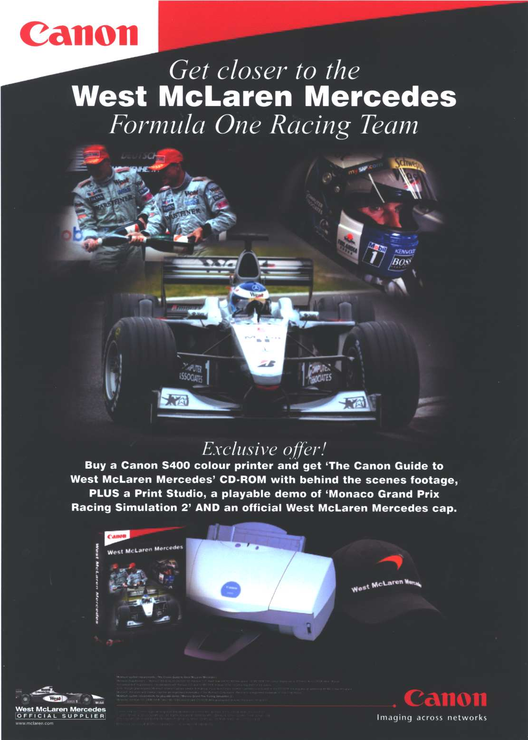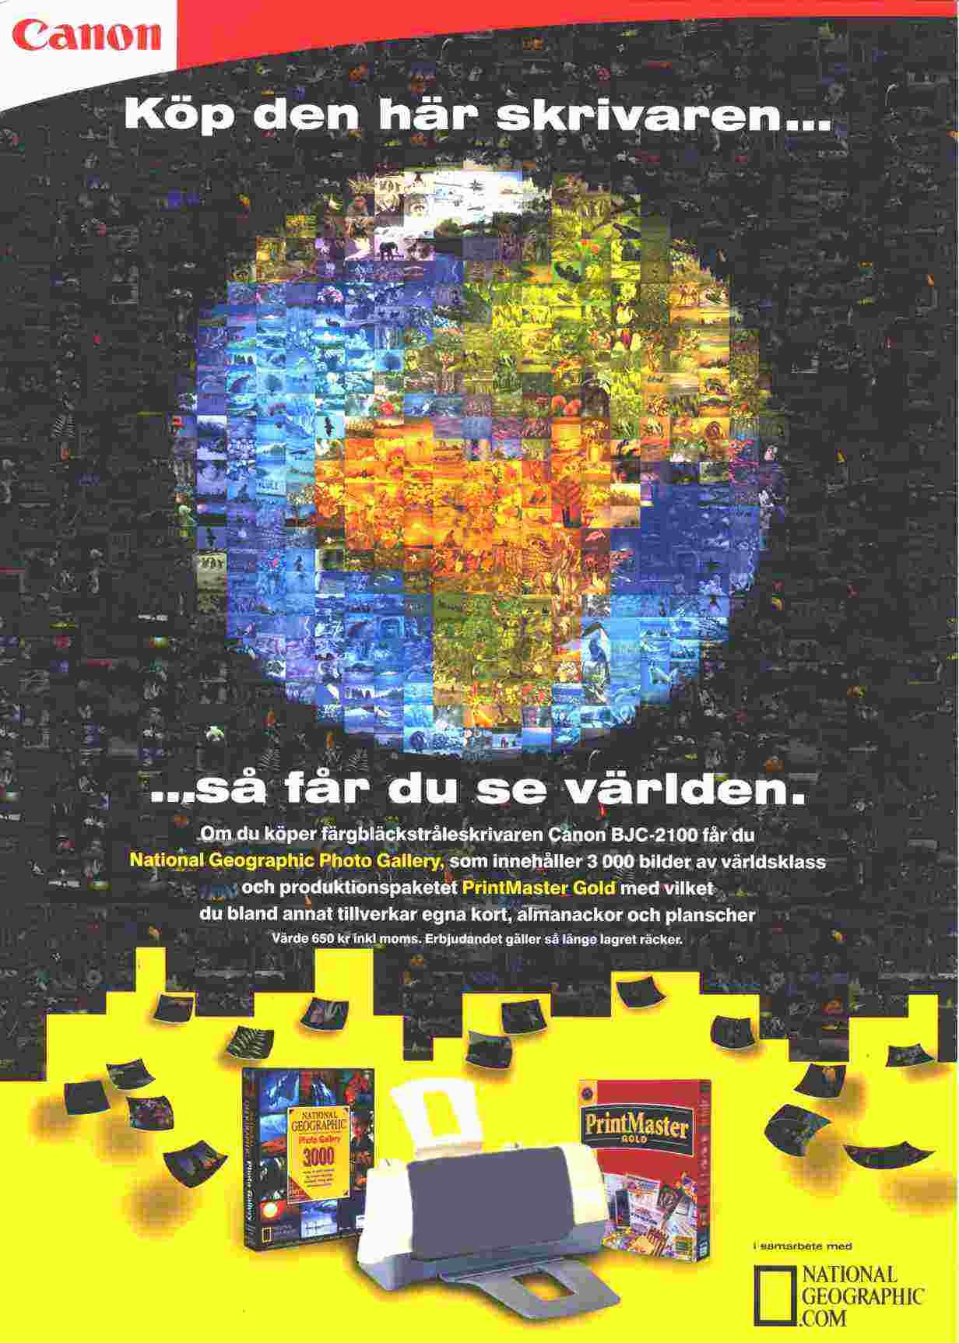

Other

Review the Canon “Who Wants To Be A Millionaire?” Promotional Product Packaging
Tactics
Canon Digital Imaging products (inkjet, laser etc) who purchased a Canon printer, received an in box product incentive.
Also, the opportunity to Win a Canon Digital Camera worth £299.95 SRRP / €499.00 SRRP (Who Wants To Be A Millionaire?” campaign.
Results
• Increased consumer product / brand visibility
• Increased sales
• Product sell through time decreased
For more detail on this program, contact us today!

