Client: Kellogg’s UK, Scandinavia

Objective
Increase Sales and Channel Sell Through. Added value via in box consumer offerings.
Strategies
Leverage off Football World Cup Event
Stimulate and influence “purchasing” dynamics
Influence sell through cycles

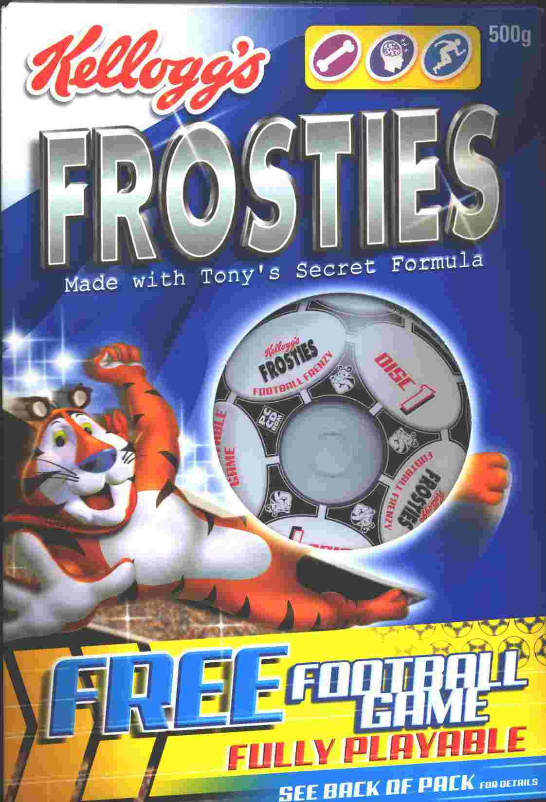

Tactics
Kellogg’s Frosties consumers who purchased a box of Kellogg’s Frosties received a fully playable interactive bespoke football game.
Multi CD’s collection (one per box) to encourage consumers to collect the full product set (4), and therefore influence sales.
Deploy affinity in game branding.
Results
• Increased consumer product / brand visibility
• Increased sales / multi sales (consumers often bought more than the traditional single box)
• Product sell through time decreased significantly

Promotional Product Size
• In excess of 5 million units

Program notes

• Special bespoke programming of the product required and an understanding of interactive game design mechanics. Please conatc us to understand in further depth the unique attributes of this program.

• The success of this program lead to a subsequent program based on Formula 1 racing season.

For more detail on this program, contact us today!

