Client: Dell Computer Europe

Objective
Increase awareness of DVD technology deployed on Dell Personal Computers.
Position as value added technology [DVD] market leader in consumer PC sector
Strategies
Show technology off through free film product
Leverage off famous film studio titles
Through viewing film trailers encourage consumers to use their PC’ s as an alternative TV/Video/ DVD standalone medium.

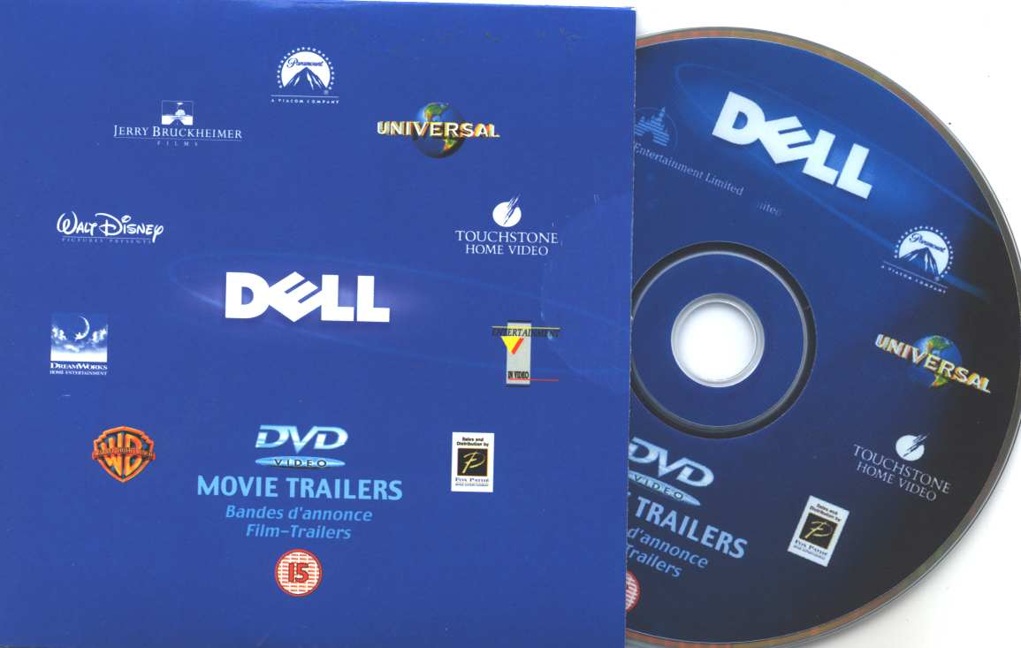

Tactics
Liaise with studio partners to provide a product containing over 20 film title.
Ensure broad film trailer genres to fully encapsulate all demographics
Results
• Increased consumer product / brand visibility
• Increased awareness of Dell Computer DVD PC capabilities

Promotional Product Size
• In excess of 100,000 units.

Program notes

• Special bespoke programming of the product required to ensure consumers could select film trailers and not be forced to watch in a one dimensional method.

For more detail on this program, contact us today!

